Quantitative Module E

Learning Curves

**Background**

Take a look at the caption for the surgery photo at the very beginning of Module E. Do students understand what a 79% learning rate in this example implies? Instructors might consider telling students that learning curves represent the most important topic in all of OM. If they pay attention, it may save their life. Why? Research indicates that the death rate from heart transplants drops at a 79% learning curve. Now, when choosing a surgeon, should the students choose one working on her fourth patient or should they choose one working on her 2048th? (Starting with any death rate *D* for a brand new surgeon, the novice surgeon on her fourth surgery will provide the student with a 0.6241*D* chance to not survive the surgery, while the experienced surgeon will provide the student with a 0.0748*D* chance to not survive the surgery. In other words, the novice’s fourth patient is over eight times more likely to die on the operating table than the experienced surgeon’s 2048th patient is!)

Students should be able to relate to the concept of learning curves because they surely have experienced it themselves. Whether it’s solving calculus problems, playing table tennis, or talking to members of the opposite sex, most people improve with experience. The phrase, “practice makes perfect,” is actually referring to learning curve effects. There are exceptions, of course, due to injuries, aging, forgetting, etc., but at least for the initial learning of any task, the learning curve applies quite well. The key is to estimate *how* *fast* the learning is occurring in order to make predictions about the future.

Companies learn as well, whether via their people, machines, or processes. Firms that place an emphasis on employee training, new technology, and process improvement tend to learn faster. And with two competing firms, the long-term impact of learning is much more dependent upon the speed of learning than on the initial cost or time. Managers often ignore learning curves effects; however, learning curves may be particularly applicable for situations such as: (1) future employee planning and scheduling, (2) submitting bids for the production of a customized product, (3) strategic pricing of new products in a competitive environment, (4) budgeting and financial planning, and (5) inventory theory (as it pertains to production rate (POQ model), production cost (impact on holding cost), and setup cost (which also drops with experience)).

**Class Discussion Ideas**

1. As an introduction to the topic, instructors can mention that in industries such as electronics, production costs seem to drop rapidly, and the sales prices for these types of items seem to decrease over time as well (think about calculators, HDTVs, etc.). Instructors can then ask students why this might be happening. Sample answers could include workers completely tasks more efficiently, automation, changes in methods or personnel, changes in tools, more specialization of labor, changes in product design to make it easier to produce, changes in supervision, and improved production scheduling and inventory control. Most or all of these ideas can be considered to be ways in which the firms “learn.” In other words, learning is not only referring to workers being able to physically assemble things faster. Producing *smarter*, whether via the workers themselves or with management assistance, is also a very effective and important component of learning.

**Active Classroom Learning Exercises**

1. Using a small 8 – 10 piece Lego-type toy, have a student make several (3 – 5) attempts to assemble the toy. Have a second student time each attempt and then have the students use the data to generate a learning curve. If you can use several different types of toys with similar part counts and complexity, have several student teams work on this. As an interesting demonstration, have the students change roles after the first exercise is complete. Having watched the first exercise, the observer often feels as though he or she can clearly do a better job, but most often their experience is the same as that of the original participant. This demonstrates the importance of the physical element of learning. Just observing the work is not enough.

**Cinematic Ticklers**

1. *The Simpsons, Season 1: “Moaning Lisa,”20th Century Fox Video, 2001 (1989-1990)*

This episode presents a side story about learning showing up in five segments that can be clipped together. At the beginning of the episode, Bart trounces his dad Homer in video boxing. Homer has nightmares about this and decides to visit the video arcade to hire an expert (kid) to teach him how to play the game better. After spending several hours practicing, Homer feels ready to take on his son. In the last boxing scene, Homer’s boxer is destroying Bart’s and is ready for the knockout punch…;however, Marge pulls the plug on the game at the last second to focus their attention on an announcement about Lisa. Bart says, “You’re right, Mom, this is a silly game. I’d like to announce my retirement, undefeated, from the world of video boxing.” Homer sobs uncontrollably.

**Presentation Slides**

INTRODUCTION (2-1 through 2-11)

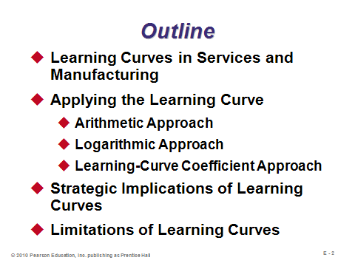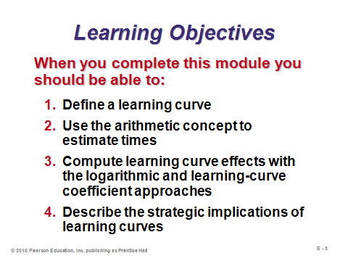

**E-1 E-2 E-3**

WHAT IS A LEARNING CURVE? (E-4 through E-6)

Slides 4-5: Slide 4 describes learning curves, and Slide 5 (Figure E.1) illustrates a typical learning curve.

Slide 6: Learning curve formulas are based on an assumption of *doubling* of production, as described in this slide. For any *T* and *L*, when these points are plotted on a graph and then connected, the curve will follow a negative exponential distribution. Obviously the doubling assumption is only an imperfect estimate, but data from thousands of studies have demonstrated that this assumption is a good one. The main question, then, is just figuring out what the appropriate learning curve rate should be.

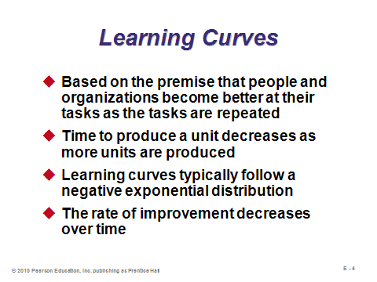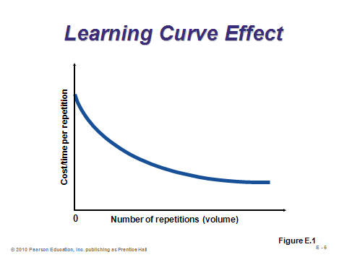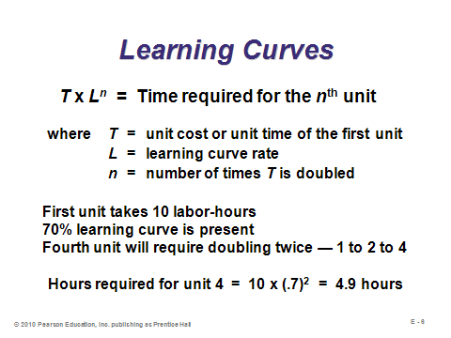

**E-4 E-5 E-6**

LEARNING CURVES IN SERVICES AND MANUFACTURING (E-7 through E-10)

Slides 7-9: These slides (Table E.1) present nine real-world examples of learning curve applications, with their associated slopes. Learning in some of these industries has been very fast indeed.

Slide 10: This slide identifies several important uses of learning curves.

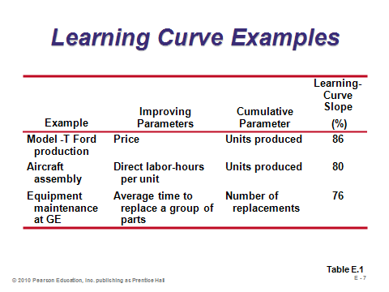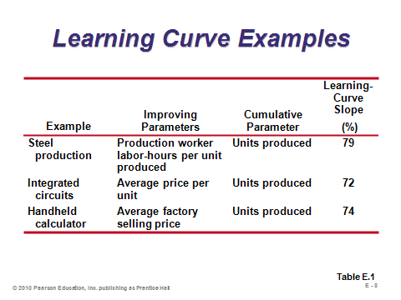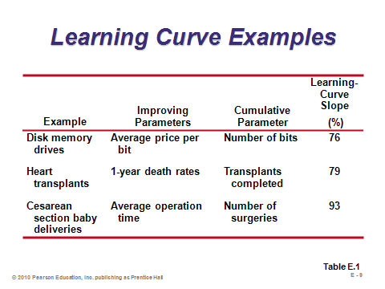

**E-7 E-8 E-9**

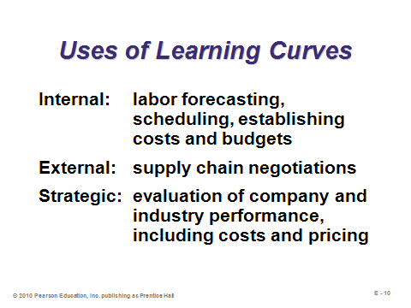

**E-10**

APPLYING THE LEARNING CURVE (E-11 through E-18)

Slide 11: The arithmetic approach can be used to easily find the cost or time of a future unit, as long as the unit in question is some doubled amount (2, 4, 8, 16, 32, etc.). In addition, this method is useful as a quick double-check giving upper and lower bounds for the estimate of any other unit.

Slides 12-14: Slide 12 presents the formula for the logarithmic approach. (Note that the log can be to any base, including *e*, as long as the same log function is used to the numerator and denominator of *b*.) Slide 13 (Table E.2) computes values of *b* for several popular learning rates. Slide 14 (Example E1) presents an example of the logarithmic method.

Slides 15-17: The *coefficient approach* uses a table to perform the *Nb* calculation for us. Slide 16 presents an excerpt from the more expanded coefficient table E.3 in the text. The table also provides *cumulative values*, which is a very useful way to compute the future costs of many units in one just calculation. (Note: To compute the cumulative time for an intermediate set of units, say units 5 through 20, compute the total time for 20 units and subtract the total time for 4 units.) Slide 17 presents an example of using the coefficient approach to compute the time of one future unit (Example E2), as well as the total time for the first four units (Example E3).

Slide 18: If the recorded time of the first unit is either unknown or no longer valid, a revised estimate for that first unit can be computed given the known time of a later unit and an estimated learning curve rate. Just apply the coefficient approach in reverse. This slide illustrates with an example (Example E4).

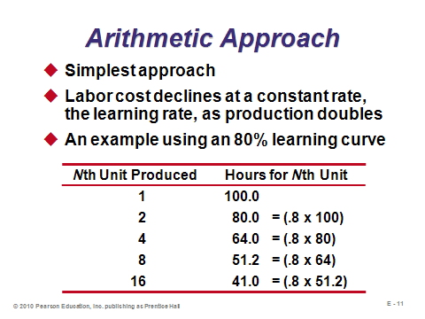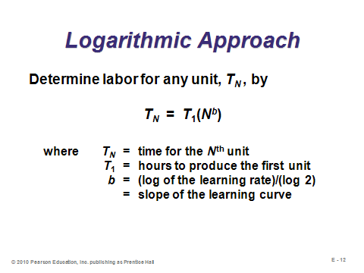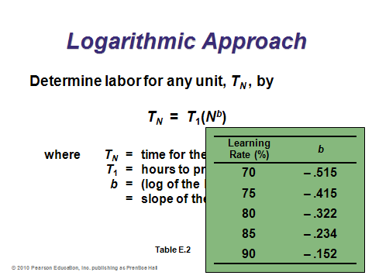

**E-11 E-12 E-13**

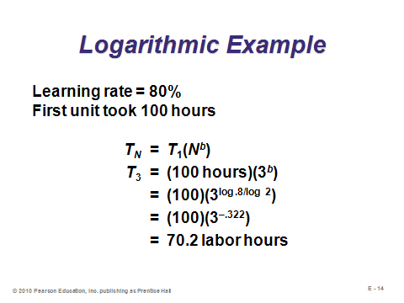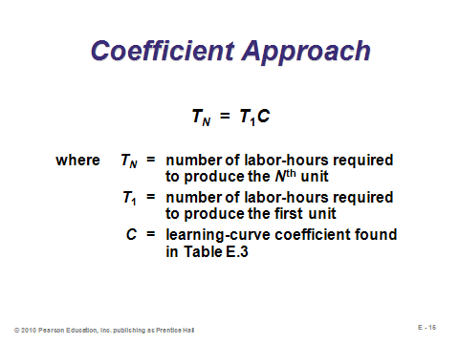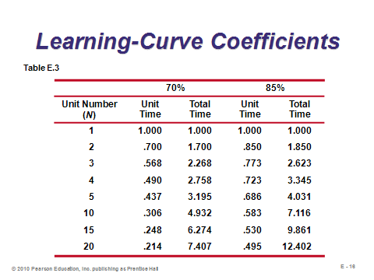

**E-14 E-15 E-16**

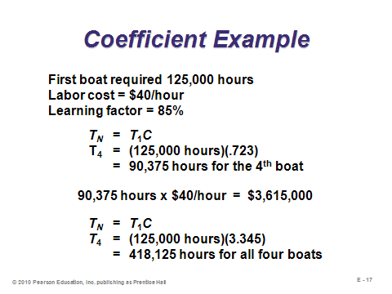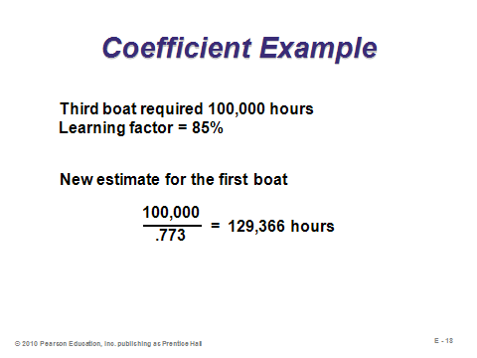

**E-17 E-18**

STRATEGIC IMPLICATIONS OF LEARNING CURVES (E-19 through E-20)

Slide 19: This slide presents good methods for trying to outpace competition via actively pursuing learning curve benefits. The concept behind point 1 is that if a firm sets a low sales price for the product, then it may be able to gain market share, implying a higher sales volume. To sell more, the firm has to produce more, and that drives the cost down through learning. So even if initial profit margins are very slim, this practice may ultimately lead to an excellent market position—high market share bolstered by a low sales price and produced with low costs, implying many units sold times a healthy profit margin.

Slide 20: As this slide (Figure E.2) suggests, in an industry with learning that puts downward pressure on sales price, competing firms must keep up with a learning rate as least as fast as the industry’s in order to remain competitive.

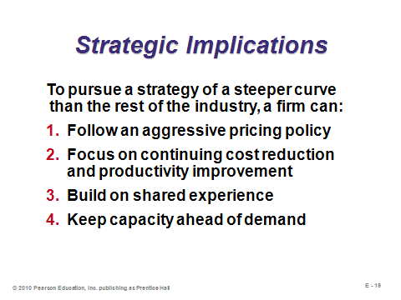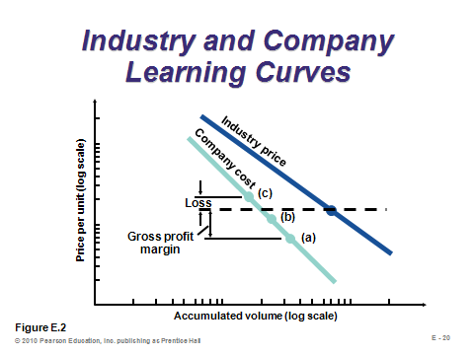

**E-19 E-20**

LIMITATIONS OF LEARNING CURVES (E-21 through E-22)

Slides 21-22: The learning curve has certain limitations, which are described in these slides. In general, the formulas only provide estimates and they are based on data from early units, so the estimates may need to be re-evaluated as conditions change. For example, years ago when the F-4 fighter was being phased out at McDonnell Douglas, its time-to-assemble *increased*, in particular because all of the top workers were moved to the F-16 line. Phase out had a major impact in this instance.

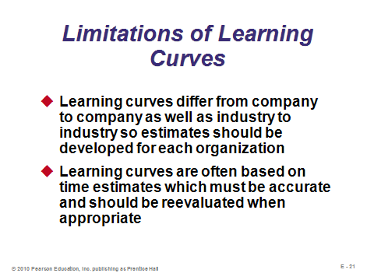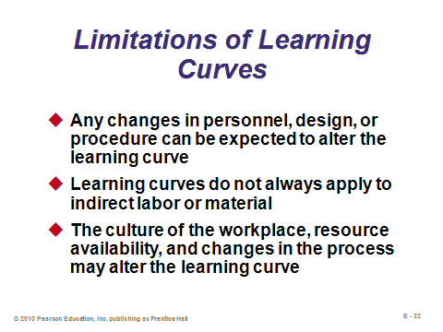

**E-21 E-22**

**Additional Assignment Ideas**

1. Visit, read about, and experiment with the learning curve calculator at:

http://www.fas.org/news/reference/calc/learn.htm

Write a short summary of things that you learned that are not addressed in Module E.

**Other Supplementary Material**

A Flexible Version of the Learning-Curve Coefficients Table

What if the coefficient approach is desired for unit numbers or learning curve rates that are not provided in Table E.3? While it may be easy to see how to replicate the *Unit Time Coefficient* columns in Excel, the *Total Time Coefficient* columns are a bit trickier. The Excel screen shot of formulas below shows the formulas behind the calculations for creating as large of a table of cumulative coefficients as desired. The formula actually only needs to be entered once (see Cell B6) and then copied. As long as the dollar signs (for anchoring) are entered correctly, the formula can be copied down for any value of *N* desired and copied over to make new columns for new learning rates. (Just make sure that the units in Column A are numbered consecutively.) If only a different learning rate is desired, the coefficients in Column B will all recalculate correctly by simply entering the desired rate into Cell B4. Such a spreadsheet could be provided for students.

